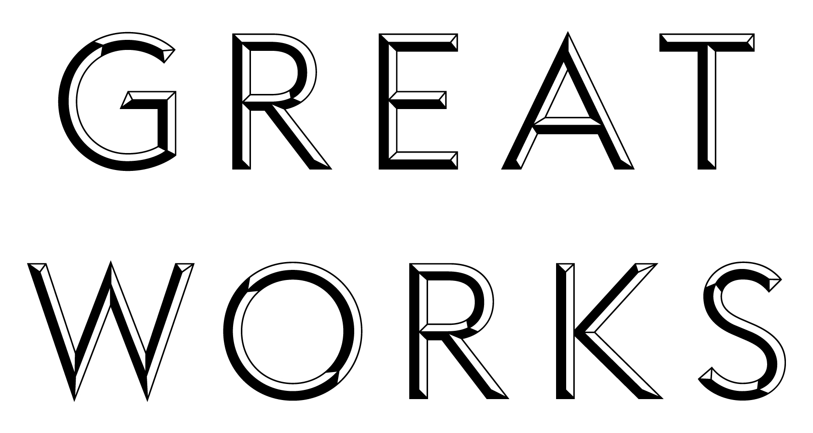
Press Release
Date of issue: 15 November 2016

MAJOR NEW WORK BY GLENN BROWN ACQUIRED FOR THE LAING ART GALLERY, NEWCASTLE, THROUGH THE GREAT WORKS SCHEME

The internationally acclaimed Glenn Brown has produced a major new work, specifically for the Laing Art Gallery in Newcastle, making it the first donation made through the Contemporary Art Society’s Great Works scheme.

‘In the end we all succumb to the pull of the molten core’ (2016) shows the turning heads of two men – one young and one old – laid on top of each other, seeming to split in opposite directions. Drawn in Indian ink and painted with acrylic on panel, these two portraits, appropriated from images by Giovanni Domenico Tiepolo and Andrea del Sarto, merge into one in a writhing swirl of fast lines and swiftly marked gesture.

The Great Works scheme, generously supported by the Sfumato Foundation, aims to tackle the absence in UK museums of works by major British artists over the last 20 years. This will be the first piece by Glenn Brown placed in a UK museum collection and the Laing Art Gallery is significant to the artist having first visited as a child growing up in Hexham, some twenty miles from Newcastle.
Glenn Brown: “The Laing Art Gallery is a very special place, not just because it was there that I first encountered art, but because now, 45 years after I first went through its doors, it is even more full of great art. To me, as a painter, it is the North East England's most important building and collection of art. Museums are vital to the future of any city, as culture can only move forward if it knows where it has been, if it understands its history.
‘In the end we all succumb to the pull of the molten core’ was made with Newcastle and the Laing in mind. It is a painting that looks forward (the youth) and looks back (the old man), but they are one and the same, entangled in a complex game of sitting in the present. The heads could be trapped in religious ecstasy or they could be in outer space. You might think it beautiful or really rather ugly. In the end I don't want it to illustrate any one idea - I am happiest if it just seems like a complicated arrangement of abstract lines.
It is a great honour to work with the Contemporary Art Society. A piece of art is an act of communication, which only works if it can be seen, and works most effectively when it is seen by many. The CAS has a long and effective history of helping art to communicate its message.”
Caroline Douglas, Director of the Contemporary Art Society: “Whilst the Contemporary Art Society is principally known for buying artists early in their career, we are acutely aware that decades of funding pressures have left gaps in collections across the country. Future generations will find it inexplicable that through a period of unprecedented international acclaim for a generation of artists working in Britain, so many of our public collections have been unable to collect examples of their work. Once a year, through the Great Works scheme that has been established with the support of the Sfumato Foundation, we will attempt to address this situation. It is also thanks in large part to the great generosity of the artist that we are able to respond to the Laing Art Gallery’s desire to make this inaugural acquisition of work by Glenn Brown.”
Julie Milne, Chief Curator of Art Galleries (Tyne & Wear Archives & Museums): “One of the strengths of the Great Works scheme is that it recognizes that for many people the formative experience of art will be in regional collections and even in times of public funding challenges those collections deserve to be not only protected but enhanced. This acquisition is a major coup, raising the gallery’s profile nationally and internationally, and engendering a sense of pride in the quality of artistic talent from the region.”
This new work will go on permanent display from 20 May 2017. In 2018, to coincide with The Great Exhibition of the North (a two-month exhibition, celebrating art, culture, and design hosted by Newcastle-Gateshead), the artist has agreed to curate a show of key pieces from the Laing’s collection alongside his own work.
For over 100 years the Contemporary Arts Society has continually channelled philanthropic support of contemporary art to museums across the UK. In addition to landmark gifts to Tate, that included the first Picasso, Matisse, Anthony Caro and Damien Hirst to enter a UK public collection, the CAS has a track record of substantial support to regional museums, including the first work by Francis Bacon to Huddersfield in 1952, an installation by Olafur Eliasson to Eastbourne in 2003 and most recently a piece by Kader Attia for Middlesbrough Institute of Modern Art in 2016. The Laing Art Gallery has also received a number of significant gifts from the CAS since the organization was established in 1910, including works, amongst others, by Marlene Dumas, Duncan Grant, Peter Joseph, and Ben Nicholson.
The Great Works Scheme is generously supported by the Sfumato Foundation.

For all press enquiries please contact:
Sylvia Ross, Bolton & Quinn
sylvia@boltonquinn.com | +44 (0)20 7221 5000

Marcus Crofton, Communications Manager, Contemporary Art Society
marcus@contemporaryartsociety.org | +44 (0)20 7017 8412

NOTES TO EDITORS

About Great Works application process
Great Works enables one major work by a leading British artist to be purchased each year for a UK museum or gallery. The 70 museums across the UK that make up the CAS’s Museum Membership are eligible to apply for the award, the majority of which are outside London. Applicants are asked to make a strong case for how an acquisition of this scale would benefit the institution in relation to their audiences, scholarship and profile of the museum. In particular, the successful applicant will make the case for the acquisition of work by an artist with a substantial connection to the museum’s existing collections, city or region.

About Glenn Brown
Glenn Brown was born in 1966 in Hexham, Northumberland. Known best for appropriating art historical references in his paintings, sculptures and drawings, he begins with reproductions and transforms these images by changing their colour, position, line and size.

His work has been the subject of numerous solo and group exhibitions including the Serpentine Gallery, London (2004); Kunsthistorisches Musuem, Vienna (2008); Tate Liverpool (2009) (travelling Fondazione Sandretto Re Rebaudengo, Turin and Ludwig Museum, Budapest); the Frans Hals Museum, Haarlem Netherlands (2013); Foundation Vincent Van Gogh, Arles (2016); Des Moines Art Center, Iowa (2016) (travelling Contemporary Art Center, Cincinnati). He has a major solo show at the Rembrandt House Museum, Amsterdam opening January 2017.

The artist lives and works in London and is represented by Gagosian and Max Hetzler Gallery.

About the Laing Art Gallery
The Laing Art Gallery is home to an internationally important collection of art, focusing on British oil paintings, watercolours, ceramics, silver and glassware. The Laing Art Gallery holds regularly changing exhibitions of historic, modern and contemporary art, and events including artist and curator talks and family activities. The Laing Art Gallery is managed by Tyne & Wear Archives & Museums on behalf of Newcastle City Council and supported by Arts Council England. www.laingartgallery.org.uk

Key Contemporary Art Society Acquisitions:

- 1917: The Contemporary Art Society gave the first Paul Gauguin, Tahitians (circa 1891) to Tate, the first work by Gauguin to enter a UK public collection
- 1928: The first Barbara Hepworth (Barbara Skeaping as she was known then) was acquired. The terracotta Goose (1927-28) was purchased by Ernest Marsh through the Contemporary Art Society Pottery and Crafts Fund from Beaux Arts for £15 15s
- 1933: Pablo Picasso, Flowers (1901) is gifted to Tate, it was the first work by Picasso to be acquired by the institution
- 1946: The first work by Francis Bacon is purchased, Figure Study II, for £175 and is donated to Kirklees Museums and Galleries in 1952
- 1950: Lucian Freud, Still Life with Squid and Sea Urchin (1949) was purchased in 1950 and gifted to Harris Museum in 1952. Purchased for £75
- 1965: Picasso Three Dancers gifted to Tate
- 1992: Damien Hirst, Forms Without Life (1991) is donated to Tate, the first Hirst to enter a UK public collection
- 1994: Peter Doig, Concrete Cabin (1991/2) was purchased in 1994. It was gifted to New Walk Museum & Art Gallery.
- 1999: Grayson Perry - Designer Rebellion (1999) and Video Installation (1999) were purchased in 1999 for The Potteries through the Special Collection Scheme. The first work by the artist in a UK public collection.
- 2003: Olafur Eliasson, The Forked Forest Path (1998) purchased for Towner Eastbourne in 2003, the first of his works to enter a regional UK collection.
- 2013: Lynette Yiadom Boakye (nominated for Turner Prize 2013), To Tell Them Where It’s Got To (2013) was purchased for Plymouth for £5,000.
- 2015: Hito Steyerl, Abstract (2012) was purchased for the Gallery of Modern Art in Glasgow, the first work by Steyerl to enter a UK public collection.

