Super Flatland
White Conduit Projects 16 Sept - 18 Oct 2020
Opening: Wed 16 Sept 3-8pm
Glenn Brown, Michael Craig-Martin, Malcolm Crocker, Ori Gersht, Kate Groobey, Hannah Hughes, Yuuki Horiuchi, Paul Noble, Miho Sato, Yuichiro Tamura, Sinta Tantra, Sinta Werner, Andrea V Wright plus Floating World prints
Curated by Paul Carey-Kent and Yuki Miyake
A dozen artists from Europe and Asia inhabit ‘Super Flatland’ at White Conduit Projects. Some are there as an artistic strategy, either for aesthetic reasons or to generate confusion between what is 2D and what 3D. Others investigate the various ways in which reality might get ‘flattened’ – when it goes online, for example. There is a long history, both eastern and western, of artists being interested in flatness. The post-impressionists, most notably Gauguin, Van Gogh and Toulouse-Lautrec, adopted the aesthetics of flatness from Japanese models epitomised in the ‘Floating World’ print. The modern Japanese ‘Superflat’ movement, founded by Takashi Murakami, repurposes that history of using flattened forms as a means of critiquing the shallow emptiness of consumer culture. That originated prior to the Internet, but is consistent with similar concerns about the superficiality of the virtual world. The show’s title combines that Japanese perspective with the cult Victorian novel ‘Flatland: A Romance of Many Dimensions’ by Edwin A. Abbott, which satirically presents the possibilities of worlds in which there are one, two or four dimensions rather than three. Hannah Hughes’ collages and Andrea V Wright’s sculptures directly reference the novel. The other artists pick up the various issues raised by the two continents’ engagements with flatness. Michael Craig-Martin and Paul Noble’s drawings play between two and three dimensions. Glenn Brown creates illusions of textured surfaces. The perspectival logic of Sinta Werner’s architectural photo-collages isn’t what it first seems, and the same is often true of Malcolm Crocker’s paintings of futuristic cityscapes. Sinta Tantra’s geometric abstractions create space without quite occupying it. Kate Groobey animates flatness through pointedly comical dances, inspired by a residency in Japan. Ori Gersht’s ‘Floating World’ digital combinations of reflected gardens reference the classic Japanese ukiyo-e woodblock prints – some of which will also be included. And Miho Sato, Yuichiro Tamura and Yuuki Hourichi - appropriately in a gallery with Japanese connections - update the tradition ‘from within’.

Contemporary artists in the show
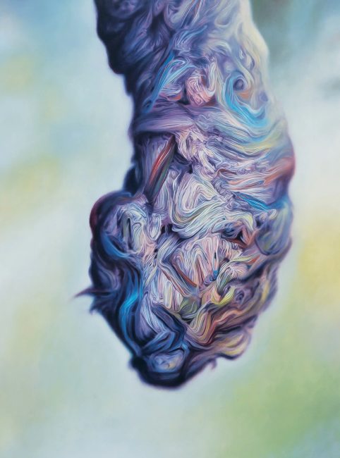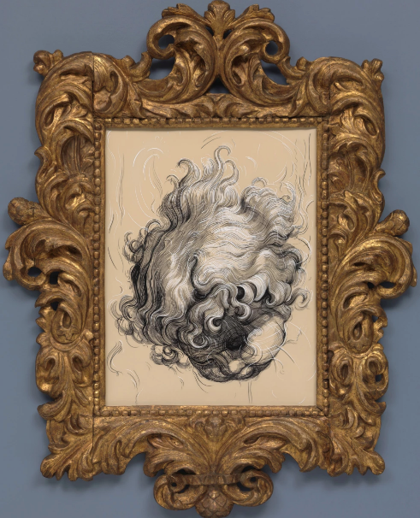
Glenn Brown: The Suicide of Guy Debord, 2001 – oil on panel, 62 x 46 cm and Fat Boy (1945), 2018 - Indian ink and acrylic paint over film on panel, with frame - 130 x 110 cm

Glenn Brown's versions of Auerbach are paintings of paint in which he flattens yet heightens the originals with hallucinogenically precise brushstrokes mimicking thick impasto. 'The Suicide of Guy Debord' sees Brown distort and invert an Auerbach portrait, abstracting the face and switching the palette to one from a painting of flowers by Renoir. Does the title allude to how, when the Situationist shot himself in 1994, some acclaimed it his purest 'critique of the spectacle'? 'Fat Boy (1945)' is a drawing about line in which the antique frame - the presenter of flatness - is picked up in the style of the drawing, so that it swells into the sculpted surround. It is more recognisably what it is, but again the title’s date changes the mood by connecting us to 'Fatman' and 'Little Boy', the nuclear bombs which flattened Japan.

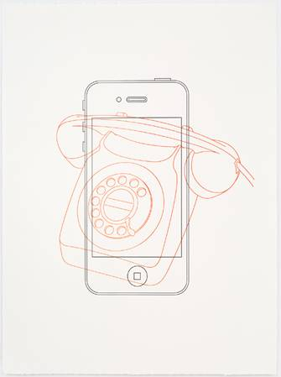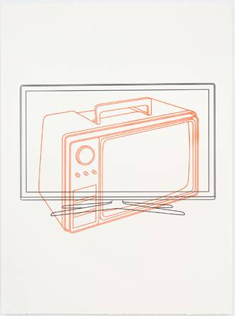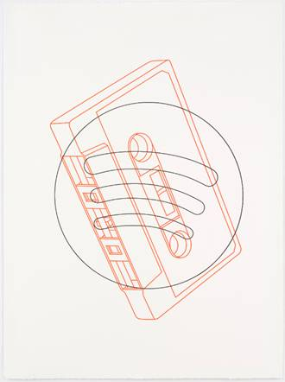

Michael Craig-Martin: Telephone / iPhone, Television / Television – above – and Book / Kindle from 'Then and Now', 2017, a series of 8 letterpress prints from two blocks, on BFK Rives white 280gsm paper with hand torn edges, each 68 x 50 cm

Michael Craig-Martin has developed a distinct vocabulary of everyday items which appeal to him for their economical design, universality and impersonal repeatability. Typically, he has depicted them in a flat drawing style, yet floated almost sculpturally in intensely-coloured spaces. Over the years, he says, that practice has made him an ‘accidental chronicler of the shift from old to new technology’. The 'Then and Now' series taps into that to show how good design shifts with the necessities of the times. And their chronological overlay becomes a further complication of the paintings’ literal and metaphorical flatness.

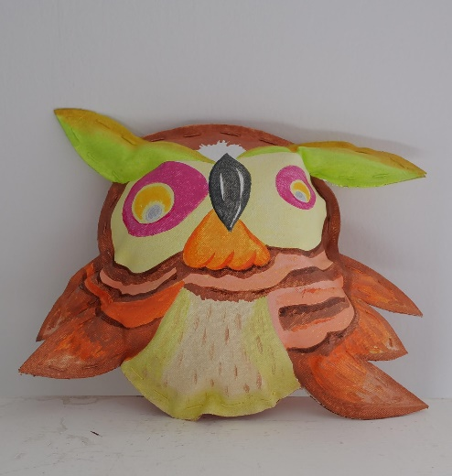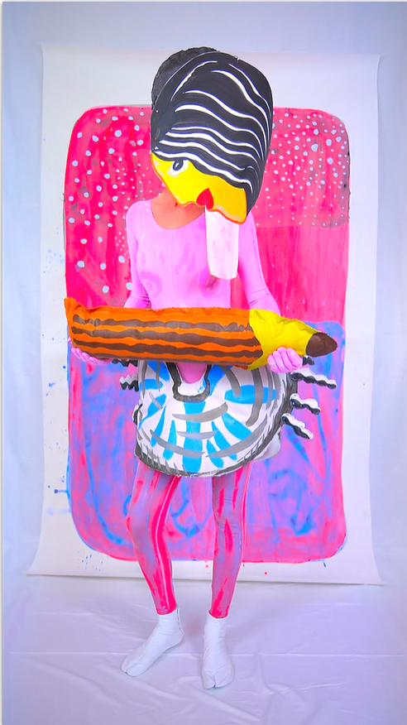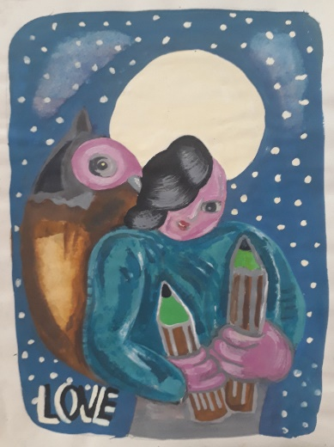
Kate Groobey: Power tools (howl), 2020, acrylic on canvas hand sewn, 20 x 25cm; Assholes of Ambition, 2019 - HD Video, 20:10mins – still above; and Owl (love) 2020 - watercolour on paper, 30 x 19 cm.
Kate Groobey has an intoxicating way of combining her own painted backdrop, dance moves, comically flat costumes, rapped words and music - thoroughly confusing levels of reality. In 2018 she saw the legendary statue of Senju Kannon, the multi-armed goddess holding symbolic instruments for the protection of her followers, in Japan. In Groobey's version a woman protects herself against the threats – whether internal or external is ambiguous – of Asshole and Stink: ‘Hey queen of poo / Whatʼcha gonna do? / Comb your soul? / It’s knotted though and through.’ Nine vignettes and nine imaginative kits see the heroine defend herself with such symbols as a giant pencil, arrows, stars and hearts. She ends as a triumphant owl: ‘Lightning strikes across my thighs / And all my enemies will die.’
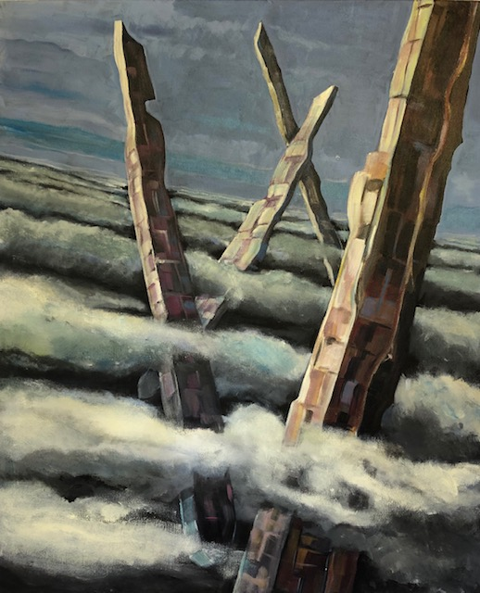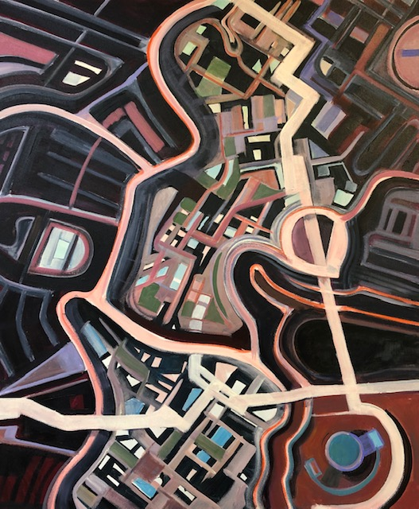

Malcolm Crocker: Penetrating and Intentions, 2020 – acrylic on canvas, each 50 x 60 cm

Malcolm Crocker is interested in how 'patterns of change, destruction, renewal, evolution, life and death are written into the geology and archaeology of our planet'. Perhaps his sci-fi-surreal cityscapes also reflect a little of his background in town planning which, unusually, preceded attendance at art college when he retired. But the practical realities of granting permissions are no restriction on his irreal fantasies, which soar above the clouds or flatten down into aerial abstraction with no limits other than the imagination's. And the titles suggest that these paintings may be - more literally - landscapes of the mind.

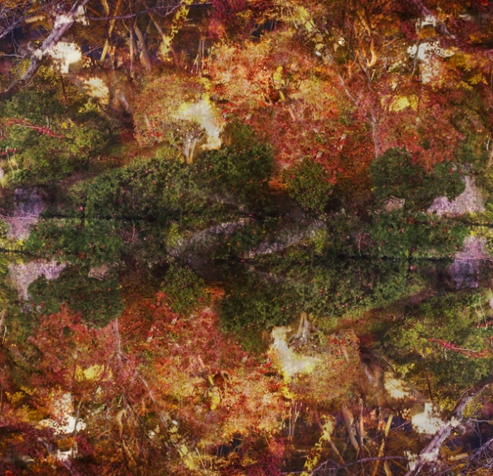

Ori Gersht: Floating World 03, 2016
​
In November 2015 Ori Gersht photographed a natural mechanism of flattening: trees reflected in the water of Kyoto’s Zen gardens. Created as places of mediation, the gardens represent an alternative to our image-saturated ‘world in flux’, hovering between everyday reality and utopian ideal. Gersht then inverted and fused his images to create places stemming from the real world, but not literally depicting it. The photograph becomes the thing that exists, an image of the folding of space and time. Moreover, the effect is to exaggerate the disturbed appearance of reality’s surface, like wind ruffling a lake, and invite us to think about what is beyond, behind, and within it – just as does the ‘floating world’ of ukiyo-e summoned by Gersht’s title.

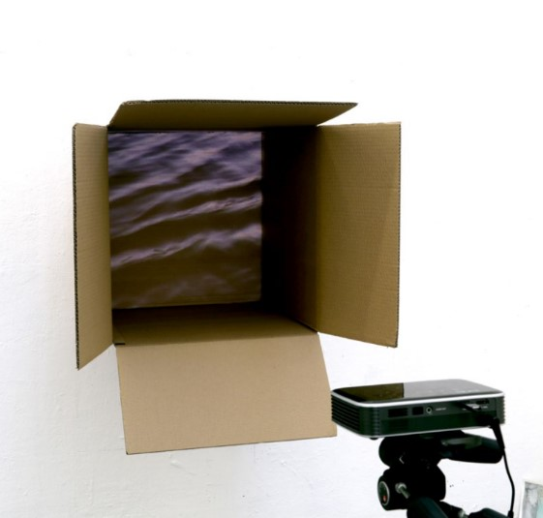
Yuuki Horiuchi: Box of River, 2019 – installation with looped video (1.20 mins) in cardboard 55 x 55 x 50 cm
Yuuki Horiuchi, who has had residencies in London recently, lives and works in Nara, Japan. She explores the connection between everyday life and universality, notably in a series of presentations which blend the natural and the human in surprising ways. She has found star charts in photographs of an asphalt road surface, trapped clouds in a TV, and projected light through wine glasses to make an eclipse – all suggesting how human interventions problematically package natural phenomena. Here she has boxed up a river. The ludicrous idea of transporting it in a cardboard box is made feasible, yet differently absurd, if we restrict ourselves to the flattening effect of packing only a representation of the water.
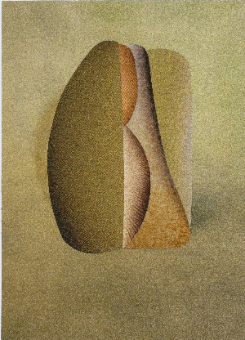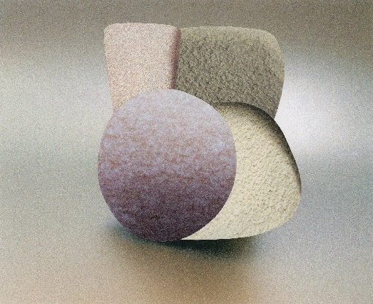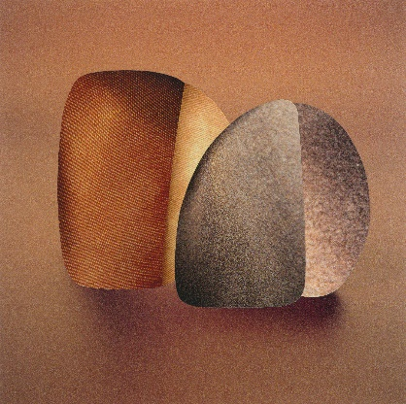

Hannah Hughes: Flatland Mirror Image series #45 (Zip Down, Spill), #46 (Static Motion, For Yvonne) and # 54 (Contradance), collages each approx. 10 cm high

Hannah Hughes refers explicitly to Abbott's novel in her 'Flatland' series, which began with her removing the main objects from images in magazines, to focus on the negative space between forms. Hughes combines these to make sculpturally-infected collages, somewhere between reproduced images and the physical world. Here she shows works from 'Mirror Image' series, in which she first uses the fragments to create shadows in new photographs, which she then cuts out in turn to form collages. In her words, they create 'spaces within, spaces in-between, spaces to travel through. They reflect an original image but are not the same... Seen together they begin to suggest symbols or glyphs, like a language with its own formal logic that can be learned by repetition...’

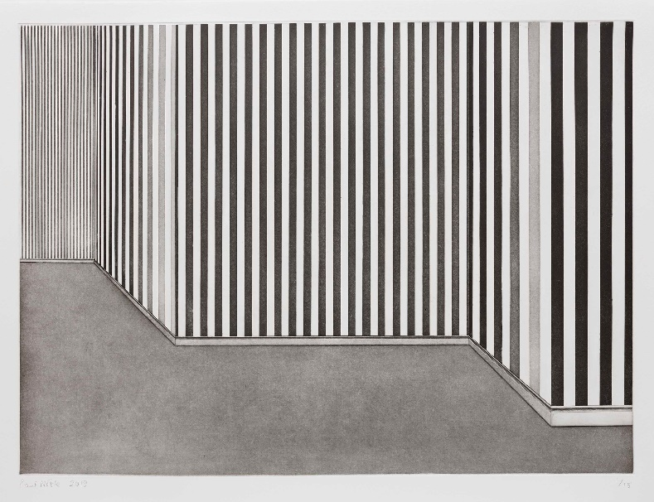

Paul Noble: Room with Wallpaper 4, 2020 - from a set of four hard ground etchings with aquatint, roulette wheel, drypoint and burnisher on Hahnemühle Etching 300 gsm paper, 61 x 80 cm

Paul Noble's Rooms with Wallpaper series show what he describes as 'sublime prisons' - there being no doors or windows to offer escape. They can also be seen, he says, as 'Grey Rainbows' and 'abstraction as wallpaper, itself abstracting the space it exists in. They are pictures of an experience AND an experience in itself.' Noble plays with the idea of foreground and background, exploiting the possibility that differentials of light and distance explain the tonal variations, yet the image somehow resists being perspectival. Result: a space interestingly poised on the edge of flatness.

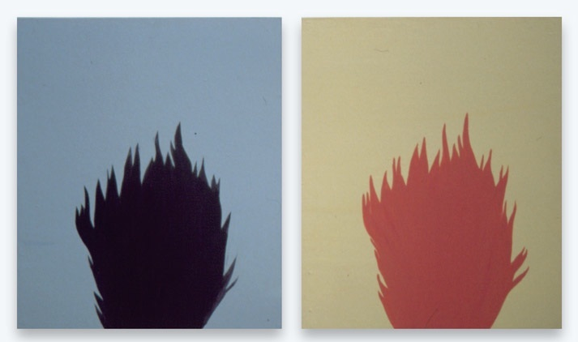

Miho Sato: Troll, 2011 - acrylic on board, each 39.5cm x 34cm

Magritte is a master of combining appearance and reality, so it's appropriate that Miho Sato picks up a fire from one of his paintings, then uses the ambiguity of its flatness to turn it into a troll – or two, as if the fire is spreading... That connects with the 'superflat' idea of bringing cute cartoons into fine art. London-based Sato grew up in Japan, so that may be no surprise. We don't see the eyes, the epitome of cuteness as emphasised by, say, Yoshitomo Nara, but that's a consistent feature of Sato's paintings, and to be expected in a silhouette - just the sort of person to live in Flatland.

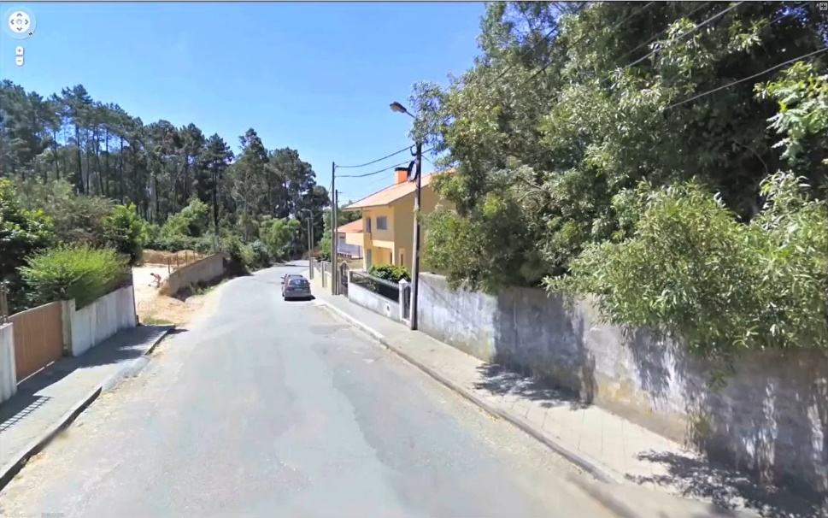
Yuichiro Tamura: NIGHTLESS ver. 11, 2013 – video, 15 mins

Yuichiro Tamura flattens time as he weaves history and fiction together in his film montage, extracted entirely from Google Street View with a soundtrack compiled from the audio in other YouTube films. As the title indicates, night never arrives, although the screen does occasionally go ominously dark and the film concludes with ‘Silent Night’. The visual enlightenment can be ascribed to the fact that Google Street view photographs are taken only by day - but the film is of Hong Kong, making it a daydream in which we are left to wonder what night might metaphorically represent in the light of recent events.

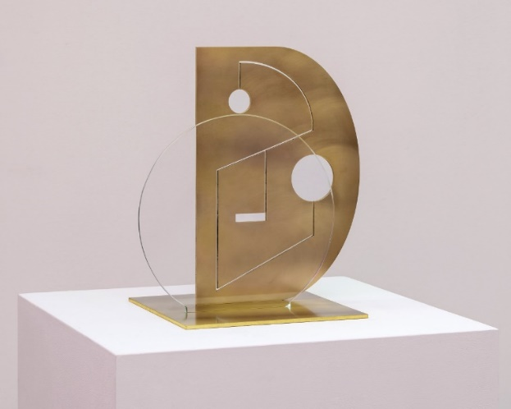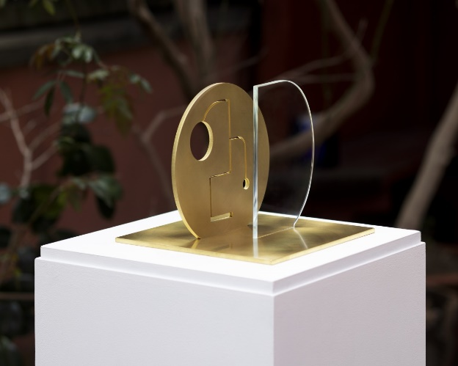
Sinta Tantra: Gambin I and Factory Worker 2020 - Brass and Glass, 20 x 20 x 20 cm and 35 x 25 x 25 cm

Charlie Chaplin’s ‘Modern Times’ is a critique of how humanity is flattened by the inexorable logic of industrial production. These sculptures come from a body of work by Anglo--Balinese artist Sinta Tantra in which she accessed Chaplin as The Tramp through the little-known link that he spent time in the pre-Westernised Bali, which he contrasted favourably with America. The more literal flatness of these near-abstract figures in brass and glass could have come from Abbott’s lands of limited dimensions. They represent the anonymous factory worker and Gambin – the supportive girlfriend of Chaplin’s character in the film. They look machine-made, but are they? And does the way they riff on Bauhaus aesthetics, and capture the changing light, provide further reason for optimism?

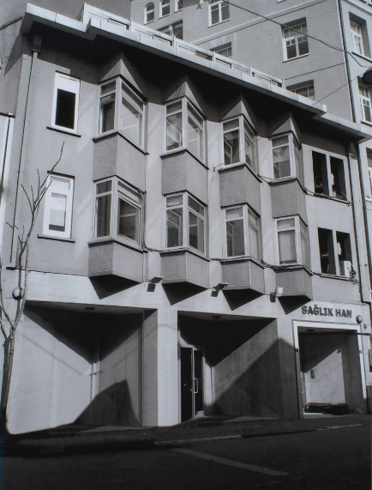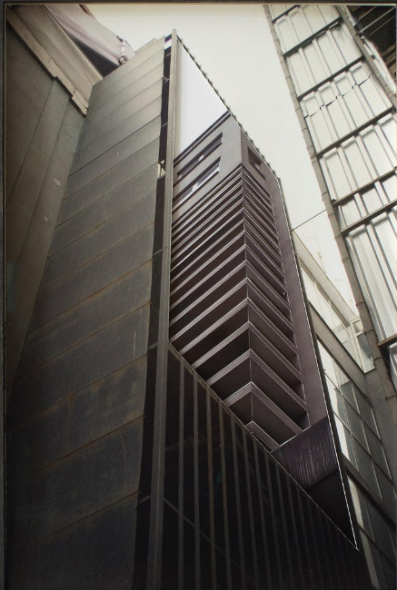

Sinta Werner: Die Flucht der Fassade II and Die Optische Undichte VIII, 2016 - Cut and folded archival pigment prints, 27 x 21 cm and 29 x 21 cm

Berlin-based Sinta Werner makes installations and collages which work across sculpture and architecture to conjure dreamlike effects. The latter are made from photographs she takes herself - here in Istanbul – as material to explore the space between two and three dimensions. Die Flucht der Fassade II might be translated as ‘the escape/alignment of the façade’ (as the German word ‘Flucht‘has that double-meaning): protruding oriels are additionally highlighted by folded elements and the glass panes of the windows are partially cut out. In this way, says Werner, ‘elements of the architecture are condensed’, subtly triggering ‘a shift or doubling of the image as one moves in front of the picture.’ In Die Optische Undichte VIII (‘The Optical Leak 8’) an opening has been cut out of an industrial façade, confusing what we see and what we see through.

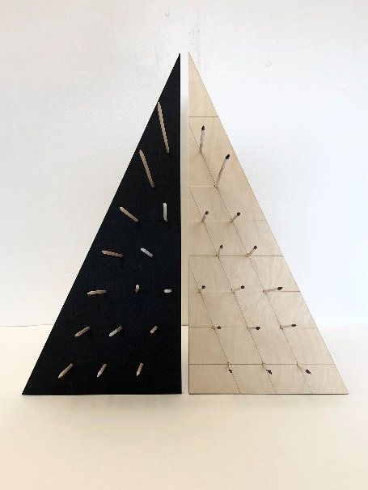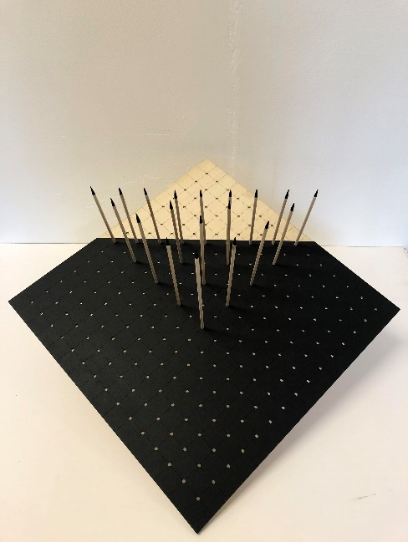

Andrea V Wright: Stealth and Cunning – 50h x 46w x 46d cm, Peace Cries 26h x 56w x 56d cm and The Rise of Isosceles 63h x 25w x 25d cm (not illustrated), all 2020 using combinations of birch plywood, card and acrylic

Andrea V Wright has previously observed that the elements of dimension and transformation in her work are comparable to those in Flatland, so it’s natural enough that her latest series reflects themes found in the book. Abbott characterises women as pointed lines, so dangerously likely to stab men who don’t see them coming front-on that they are required to making warning cries - and in Wright’s maquettes the pointed sticks can be thought of as women piercing the flatness of the card. Females aside, the triangle is the ‘lowest of the low’ in the book (circles have the highest status). Yet Wright’s triangles gain from a bristling assertiveness which might indicate the uprising of the lower classes in the novella and, through that lens, a wider indication that we should not be satisfied with any restriction in the dimensions of our world.

The Background of Flatness

Had the show infinite budget and space it would have included:

- examples of ukiyo-e
- historic examples of western painting inspired by ukiyo-e
- the original illustrations from ‘Flatland’
- examples of Superflat painting
- contemporary work which can be read in the context of the forerunning

We don’t have all of that, only the first and last, but can suggest what might have been in the middle.

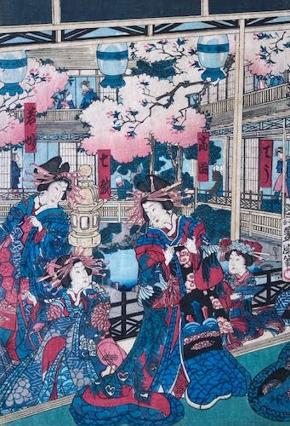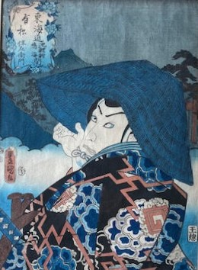

Prints by Toyokuni Utagawa (1823 – 1880)

Ukiyo-e and its influence
The Japanese term ukiyo (‘Floating World’) refers to hedonistic urban lifestyles in the Edo period (1603-1868), and ukiyo-e (‘Pictures of the Floating World’) to the woodblock prints which famously emerged from the period. This show contains examples from Utagawa and Toyohara, demonstrating the typical characteristics of sharp bold lines, forms organised in flat spaces, often cropped unusually or oriented unusually, and clear, unmodulated colours. As Japan opened up to the West after 1853, that aesthetic appealed strongly and influentially to the Impressionists and to the following generation of forward-thinking artists such as Van Gogh, Gauguin, and Toulouse-Lautrec. ‘My studio’s quite tolerable’, wrote Vincent to Theo in 1886,’ mainly because I’ve pinned a set of Japanese prints on the walls’.

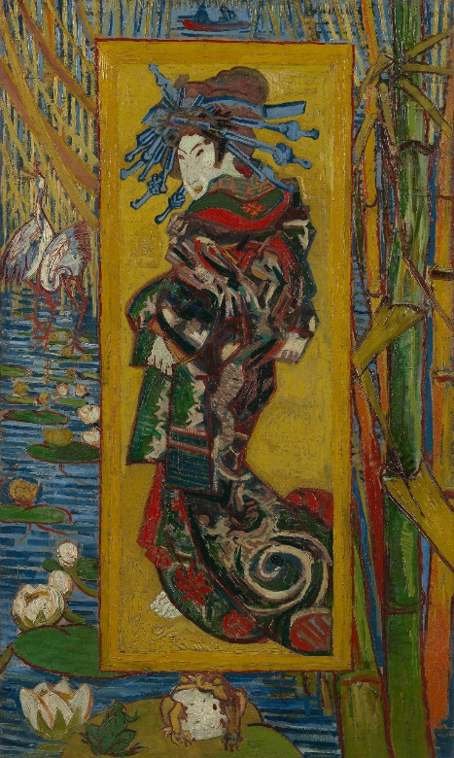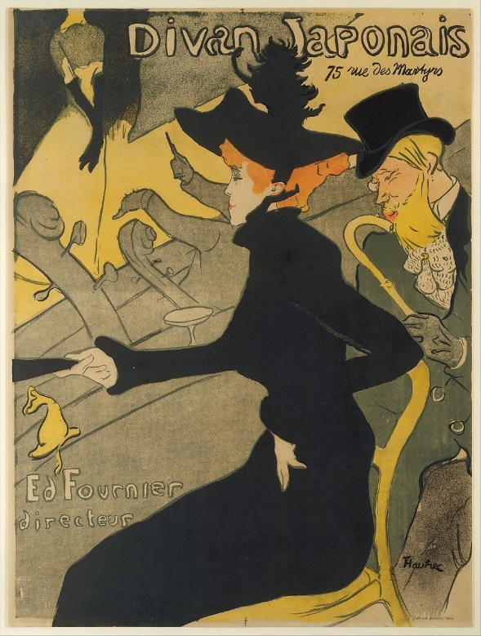

Vincent van Gogh: Courtesan (After Eisen), 1887; and Henri de Toulouse-Lautrec: Divan Japonais, 1892–93

Flatland: A Romance of Many Dimensions

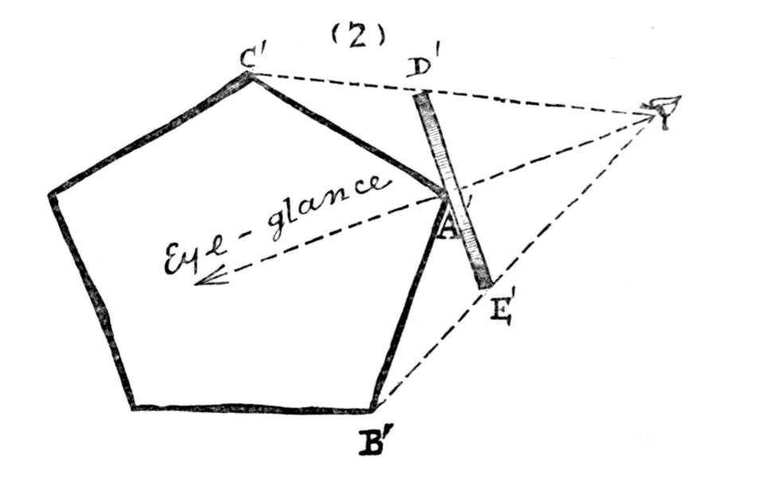
Edwin A. Abbott: illustration for Flatland, 1884
Flatland: A Romance of Many Dimensions is a satirical novella written and illustrated by the English clergyman and teacher Edwin A. Abbott, first published in 1884. It describes the journeys of A. Square, a mathematician who lives in the two-dimensional Flatland. He has adventures in Spaceland (three dimensions), Lineland (one dimension) and Pointland (no dimensions) and entertains thoughts of visiting a land of four dimensions. The book used the fictional two-dimensional world of Flatland to comment on the hierarchies in Victorian culture. Abbott delights in describing the practical challenges of life in the various dimensions and speculating on how a creature limited to two dimensions might attempt to grasp the possibility of a third. He also and makes great and amusing play with the characteristics of class and sex as reflected in alternate worlds, and how circumstances shape and restrict our understanding – witness Square’s failure to convince the King of Lineland that even second dimension is feasible. A Japanese translation of Flatland is available at the gallery!

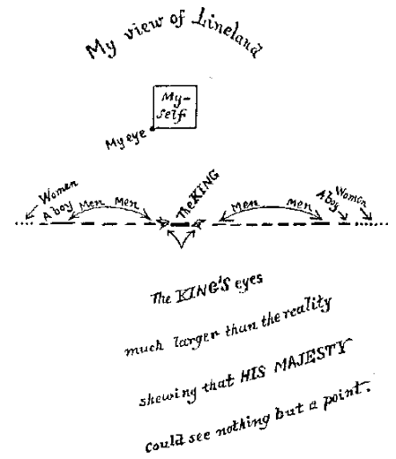

Edwin A. Abbott: illustration for Flatland, 1884

Superflat

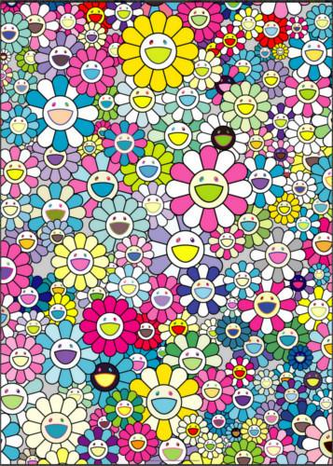

Takashi Murakami: I Look Back and There, My Beautiful Memories, 2018

‘Superflat’ is the best known postmodern art movement in Japan. Takashi Murakami coined the term in 2001 to refer to work that compressed, or ‘flattened’, various types of graphic design, fine arts and pop culture – as seen most famously in the production of Yoshitomo Nara, Chiho Aoshima and Murakami himself. As such, it is influenced by manga and anime – behind which lies ukiyo-e - as well as Western pop and the kitsch world of kawaii (‘cute’). Its ‘flatness’ refers to both the forms used and to the shallow emptiness of Japanese consumer culture – and Murakami’s Warhol-styled factory production has also flattened the distinctions between fine art and everything else. It remains unclear, though, whether the artists are celebrating or critiquing their sources.

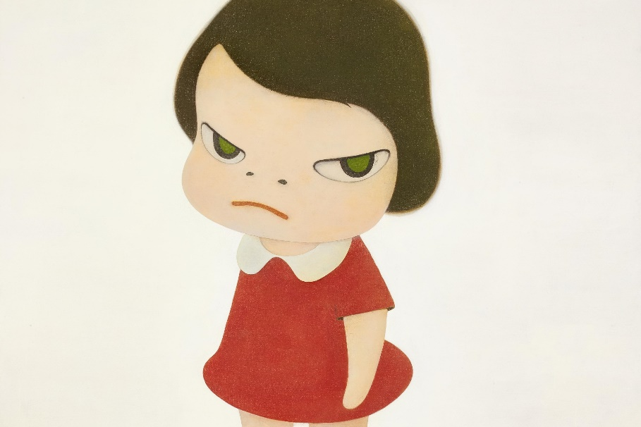
Yoshitomo Nara: Knife Behind Back, 2000

